LetsUpgrade JavaScript

Day 2 Assignment

Print Specific Character

<!DOCTYPE html>

<html>

<head>

<title>Search a specific character</title>

</head>

<body>

<script type = "text/javascript">

var str = "This is a New Beginning";

var n = str.search("h");

document.write("The character 'h' is at position : ");

document.write(n);

</script>

</body>

</html>

Output :

The character 'h' is at position : 1

Convert Minute to Seconds

<!DOCTYPE html>

<html>

<head>

<title>Convert minute to seconds</title>

</head>

<body>

<H1>Converting Minutes to Seconds</H1><br>

Note : Enter minutes to convert into seconds<br><br>

Enter minutes : <input id = "min_textBox" placeholder = "0"><br><br>

<button type="button" onclick="mintosec()"> Convert </button>

<p id="result"></p>

<script type = "text/javascript">

function mintosec(){

var min = document.getElementById("min_textBox").value;

document.getElementById("result").innerHTML = min*60;

}

</script>

</body>

</html>

**Output :**

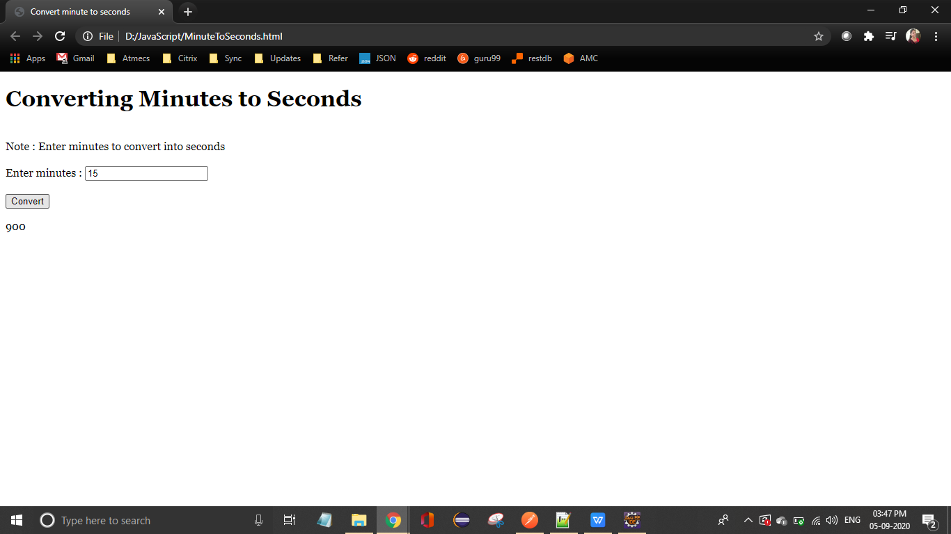

**Search for an element in an Array of Strings**

<!DOCTYPE html>

<html>

<head>

<title>Search for an element in an Array of Strings</title></head>

<body>

<H1>Find the element</H1>

<br>Note : Enter a string among the below strings to find the index of it<br><br>

"White", "Blue", "Orange", "Yellow", "Green", "Black", "Red", "Brown"<br><br>

Enter string : <input id = "str_textBox"><br><br>

<button type="button" onclick="search()"> Find </button>

<p id="result"></p>

<script type = "text/javascript">

function search(){

var str = ["White", "Blue", "Orange", "Yellow", "Green", "Black", "Red", "Brown"];

var s = str.indexOf(document.getElementById("str_textBox").value);

document.getElementById("result").innerHTML = s;

} </script>

</body>

</html>

**Output :**

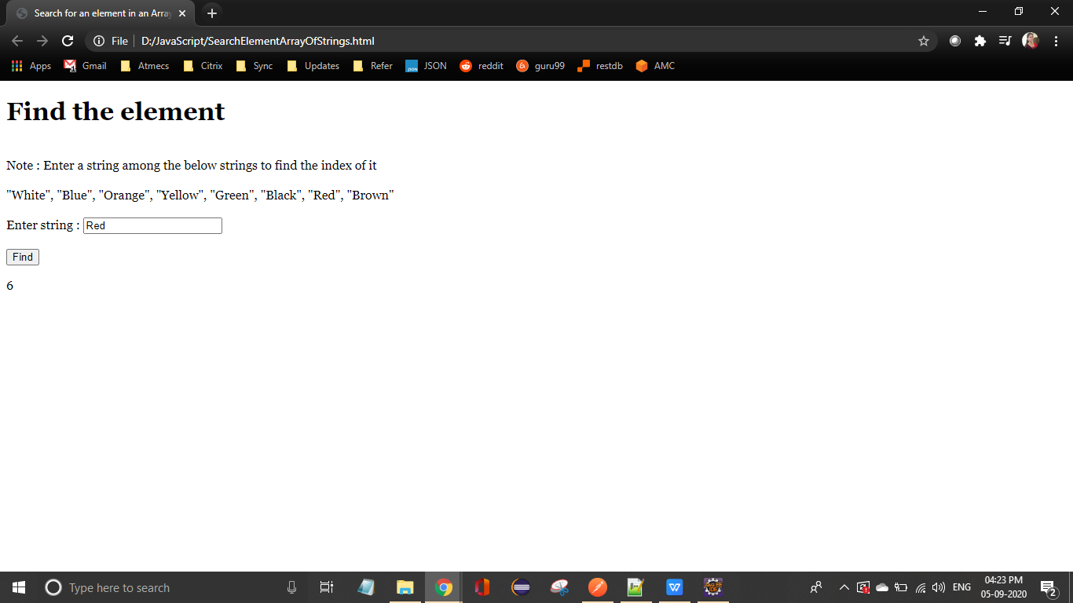

**Display elements containing ‘a’ in them from an array**

**<!DOCTYPE html>**

**<html>**

**<head>**

**<title>Display elements containing ‘a’ in them from an array</title>**

**</head>**

**<body>**

**<H1>Display the elements containing 'a'</H1>**

**<br>Note : Click on the button to display the words containing the letter in the textbox<br><br>**

**"White", "Blue", "Orange", "Yellow", "Green", "Black", "Red", "Brown"<br><br>**

**Enter letter :**

**<input id = "str_textBox"><br><br>**

**<button type="button" onclick="display()"> Find </button>**

**<p id="result"></p>**

**<script type = "text/javascript">**

**function display(){**

**var str = ["White", "Blue", "Orange", "Yellow", "Green", "Black", "Red", "Brown"];**

**var s = document.getElementById("str_textBox").value;**

**var res = [];**

**var count = 0;**

**for(var i = 0;i<str.length;i++){**

**var temp1 = str[i];**

**for (var j =0;j<temp1.length;j++){**

**if(temp1[j] =='a'){**

**res[count] = temp1.toString();**

**count ++;**

**break;**

**}**

**}**

**}**

**document.getElementById("result").innerHTML = res;**

**}**

**</script>**

**</body>**

**</html>**

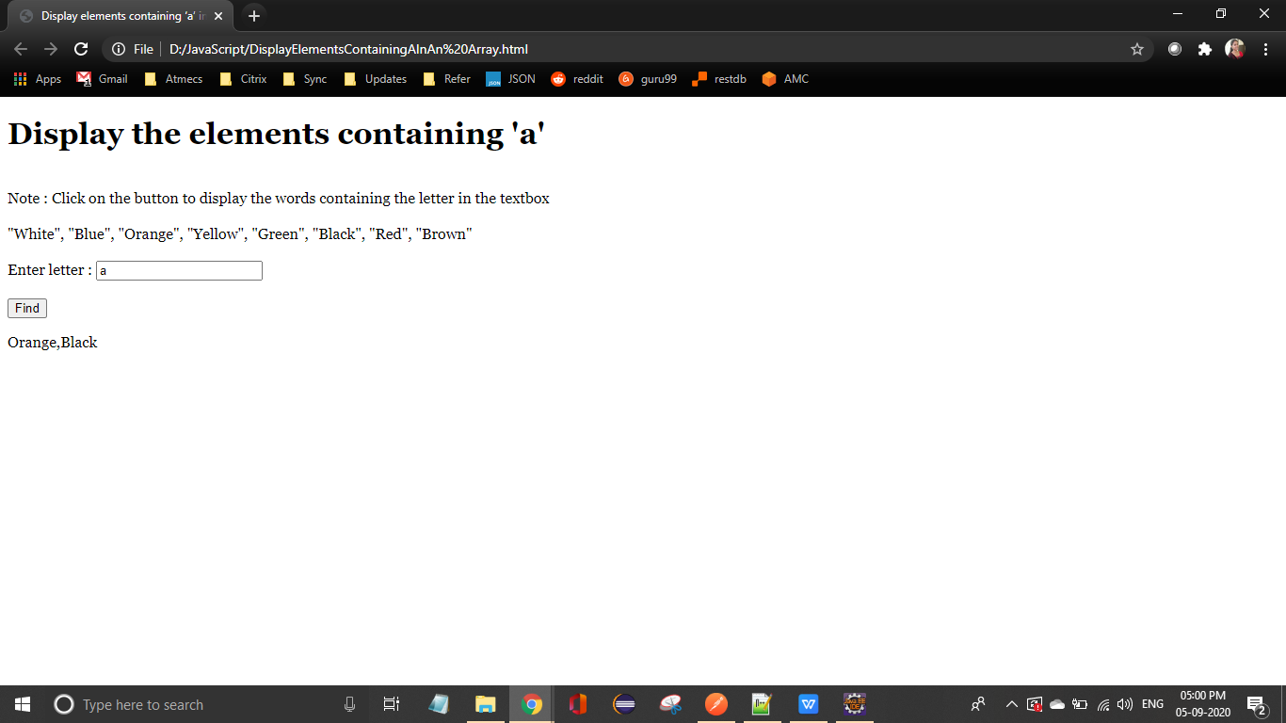

**Array in Reverse Order**

<!DOCTYPE html>

<html>

<head>

<title>Array in Reverse Order</title>

</head>

<body>

<H1>Display Array in Reverse Order</H1>

<br>Note : Click on the button to display the array in Reverse Order<br><br>

"White", "Blue", "Orange", "Yellow", "Green", "Black", "Red", "Brown"<br><br>

<button type="button" onclick="display()"> Reverse </button>

<p id="result"></p>

<script type = "text/javascript">

function display(){

var str = ["White", "Blue", "Orange", "Yellow", "Green", "Black", "Red", "Brown"];

var res = [],j;

for(var i = str.length-1,j=0;i>=0;i--,j++){

res[j] = str[i].toString();

}

document.getElementById("result").innerHTML = res;

}

</script>

</body>

</html>

